**VIDHI ROHIRA**

**S.Y B.TECH**

**SEM III**

**COMPUTER ENGINEERING**

**DAA LAB 6**

**231071052**

**BATCH – C**

**LABORATORY 6**

**LONGEST COMMON SUBSEQEUNCE:**

**INPUT:**

**POSITIVE TEST CASE 1:**

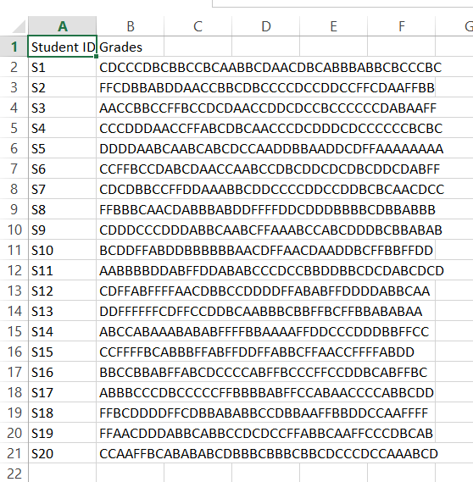

**POSITIVE TEST CASE 2:**

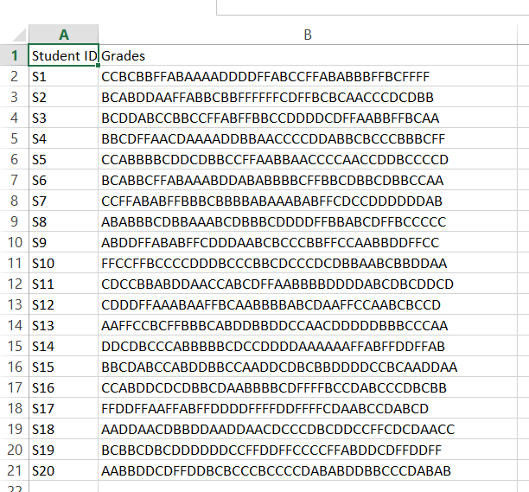

**POSITIVE TEST CASE 3:**

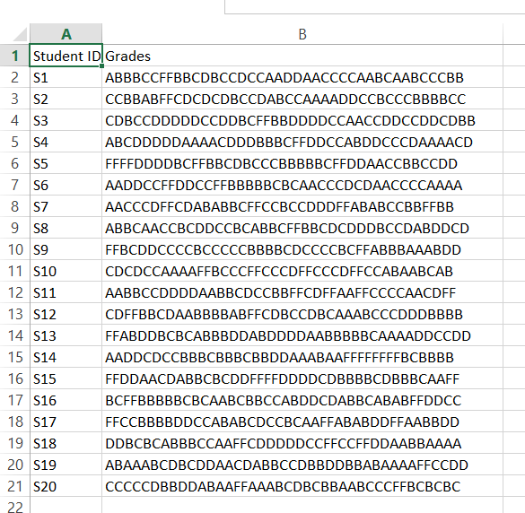

**POSITIVE TEST CASE 4:**

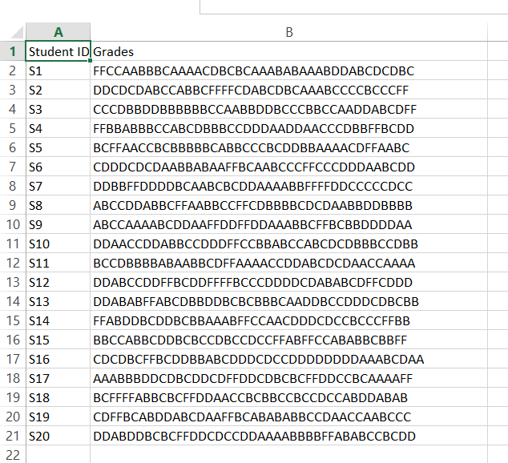

**NEGATIVE TEST CASE 1:**

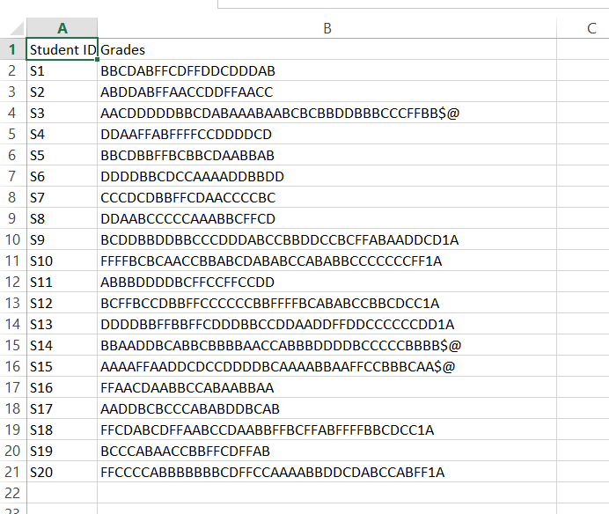

**NEGATIVE TEST CASE 2:**

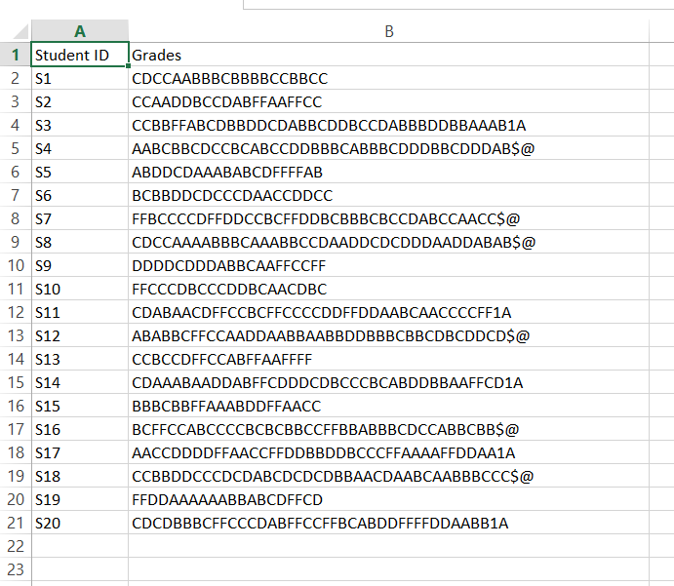

**NEGATIVE TEST CASE 3:**

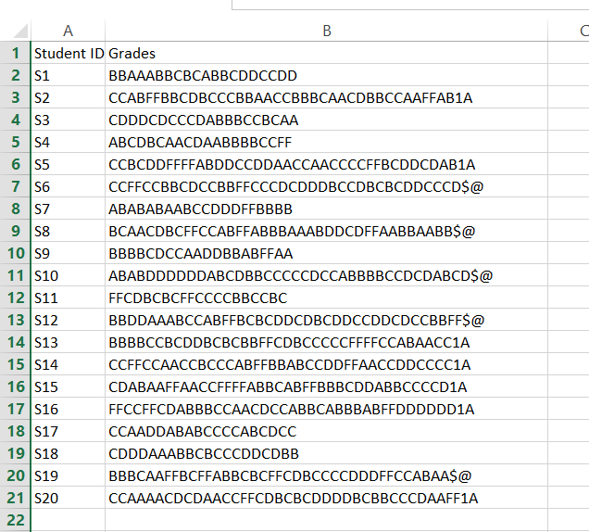

**NEGATIVE TEST CASE 4:**

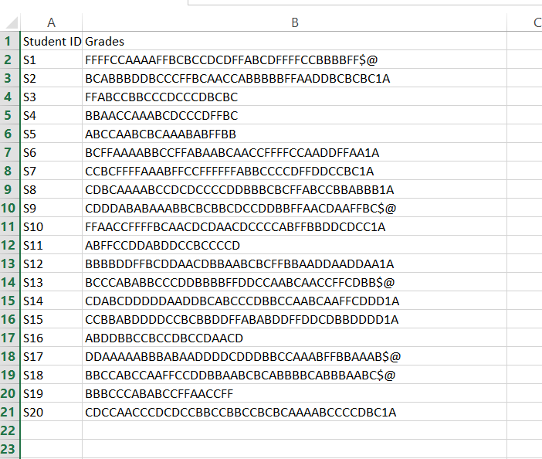

**OUTPUT:**

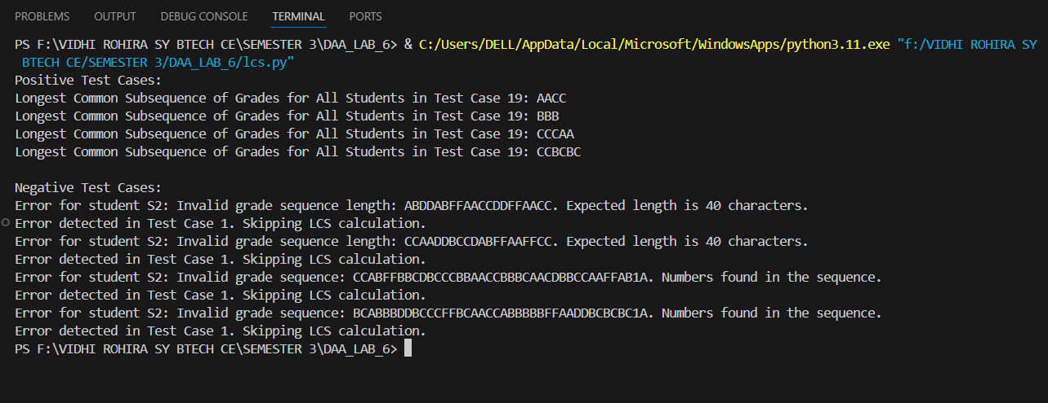

**MATRIX CHAIN MULTIPLICATION**

**INPUT:**

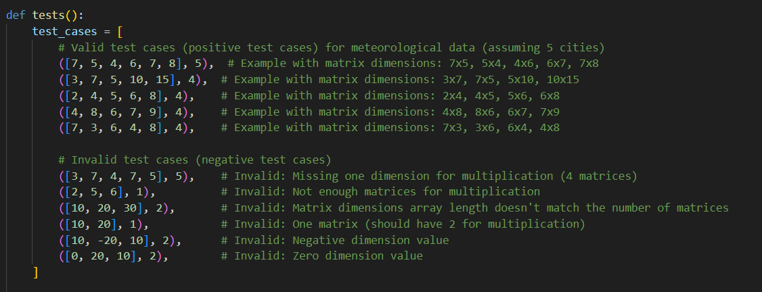

**OUTPUT:**

